K. Praveen kumar

Python Assignment-2

13-12-2023

**Data types:**

In Programming, data types are more important and below are some of the data types in python

* Numeric data types: int, float, complex number
* Sequence data types: String, list, Tuple
* Boolean data types: True, False
* Mapping data type: Dictionary

**If statements:**

1.**If**: It is used to check the given condition is satisfied or not.

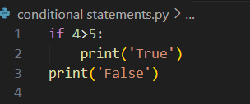

Output:

False

2.**If-else:**

If the condition in the ‘if ‘block is not satisfied the it returns to the ‘else’ block.

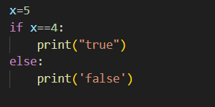

Output:

False

3.**If – else chain statement:**

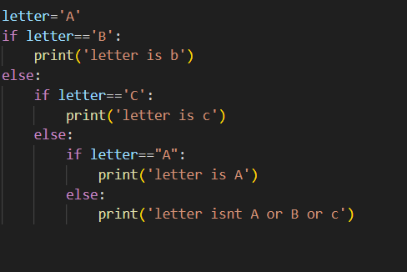

Output:

letter is A

4.**Nested if statement:**

If statement can also be written inside other if statement and it is called as nested if statement. This will check if the outer if statement is true then only the inner if will be checked.

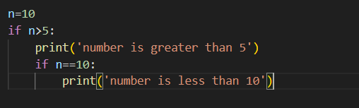

Output:

number is greater than 5

number is less than 10

5.**if-elif Statement:**

This is the shortcut of if-else chain and while using this else block is added at the end.

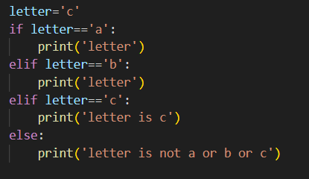

Output:

letter is c

**LOOPS in python:**

1.**While Loop:**

This is used to execute a block of statements repeatedly until a given condition is satisfied.

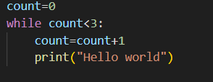

Output:

Hello world

Hello world

Hello world

Using else with while:

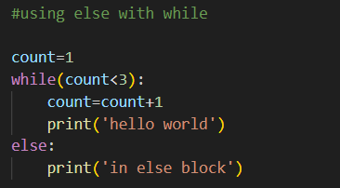

Output:

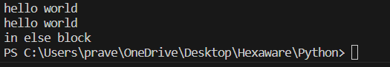

**2.For loop:**

For loops are used for sequential traversal like while traversing a list, string or array etc…

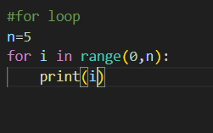

Output:

